|  |  |
| --- | --- |
| TALLINN UNIVERSITY OF TECHNOLOGY | |
| School of Information Technologies | |
|  | |
|  | |
| Jevgeni Fenko 200810IADB | |
| Online Estonian Cinema Database and Theater “Cinesta” | |
| Distributed System Course Project | |
| Supervisor: | Andres Käver |
|  |  |
|  |  |
|  |  |
|  |  |
|  |  |
|  |  |
|  |  |
|  |  |
|  |  |

Author’s declaration of originality

I hereby certify that I am the sole author of this thesis. All the used materials, references to the literature and the work of others have been referred to. This project has not been presented for examination anywhere else.

Author: Jevgeni Fenko

26.03.2022

Abstract

This project is written in English and is 19 pages long, including 4 chapters, and 6 figures.

Table of contents

Author’s declaration of originality 2

Abstract 3

Table of contents 4

List of figures 5

1 About project 6

2 ERD and its description 7

2.1 User section 9

2.2 Profile section 10

2.3 Cast details section 10

2.4 Common Person Table section 10

2.5 Movie section 11

2.5.1 Movies Standardized Details subsection 11

3 Planned platform web/app client map 12

4 Models 13

Project summary 18

List of figures

Figure 1. "Cinesta" ERD 7

Figure 2. Web/app client map 12

Figure 3. Login page model 14

Figure 4.Subscription plan chooser model 15

Figure 5. Profile creation page model 16

Figure 6. Profile Movies Library model 17

# About project

The Estonian Cinema takes the beginning in year 1986, when the first “moving pictures” were screened in Tallinn. During 36-year history, more than 236 films were filmed by Estonian Cinema Companies or in collaborations with other World Cinema Companies.

Since year 2007 Estonian Cinema every year submits films for the Academy Awards and improves production quality. We can hear, read, find more and more information about Estonian Cinema projects. Our movie theatres show more Estonian movies from year to year.

However, there is still no good platform (like Netflix) interested in our movies and it is hard to find a legal digital version of any film online.

The idea of my project is to fix the situation and create the platform, where movies and series from Estonian Movie Companies will be collected and available for users online.

The platform will use popular nowadays “access by subscription” model, where copyright owners will get their royalty fee from it.

Each user will be able to create several profiles with restrictions by age, so each profile will have only not restricted by age movies in library. Also, each profile will have an option to create own favorite movies library.

As in any good movie database, movies will have International Movie Database Score and user ratings system.

One of the most problematic points, as in every database, which must also have good search engine and good navigation between items by choosing any parameter, is standardization, as differently named key parameters may ruin UI experience. Therefore such parameters as Age Rating, Movie Type and Movie Genre will have their own tables with predefined (used nowadays) inputs with ability to update later in case if rating systems will be changed or invented more genres.

# ERD and its description

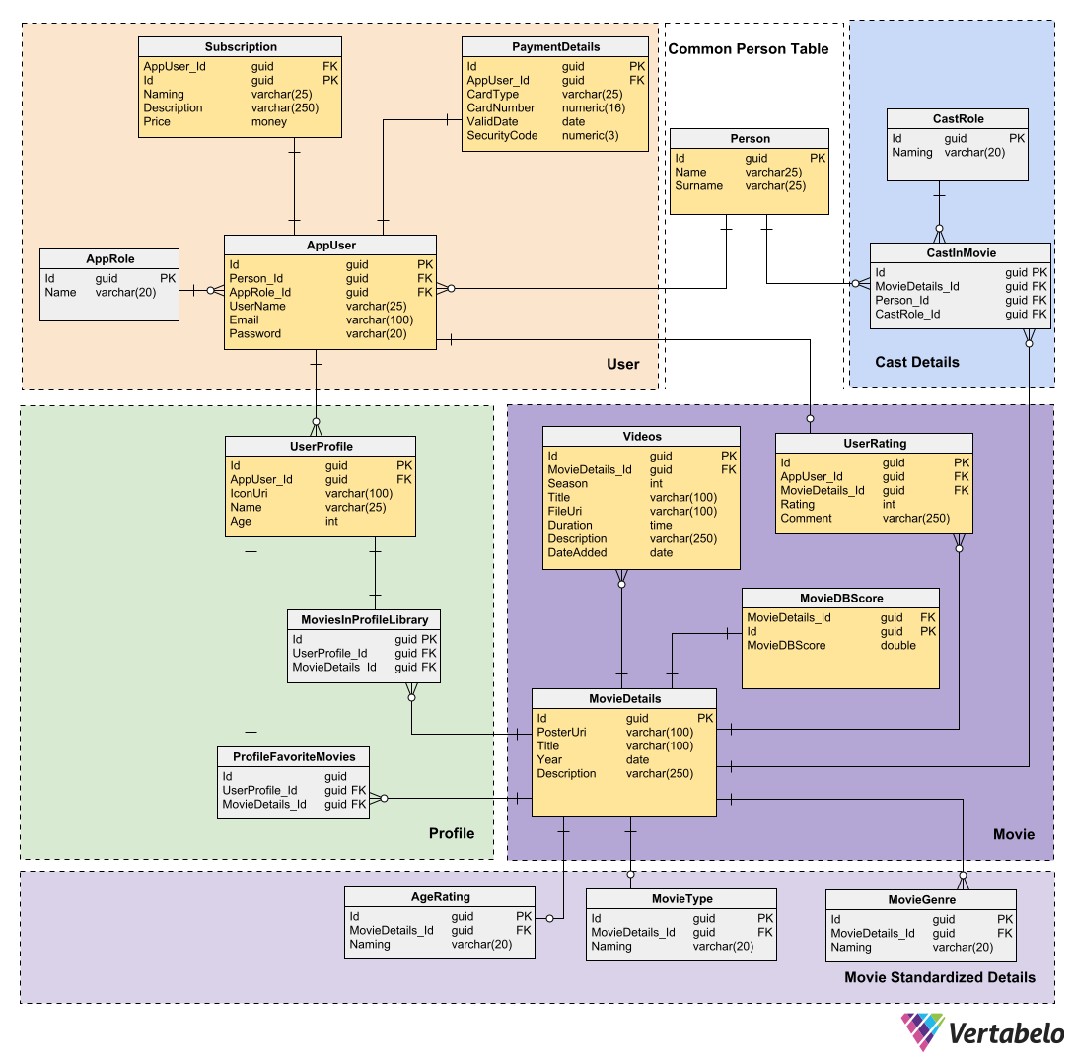

Figure 1. "Cinesta" ERD

The ERD itself can be divided into 5 sections:

1. User section with tables required for proper logging in, payment and subscription operations.
2. Profile section with tables data about user profile and correspondent profile movie libraries.
3. Cast details section for movie cast
4. Common person table. I also had to use common table for users and cast, as the same person can be a movie actor or director and at the same time user of the platform.
5. Movie section – a system of tables for movie data. It also has a subsection with dedicated tables for standardized movie details.

## User section

**AppUser** – A modified ASP.Net user table.

The table stores user account data as username, password, email. The name and surname of customer stored in Person table and linked to **AppUser**. Also, the table linked to Subscription and PaymentDetails. Each user may have one subscription and one payment type, but can change them on his will, so they must be linked, not stored in **AppUser**.

**AppRole** – ASP.Net user role table. Linked to AppUser and contains name of role for account.

**Subscription** – Table contains names, descriptions, and prices of subscriptions.

**PaymentDetails** – Only credit card payment planned at start. The table holds type of card (automatically encoded from card number), card number, validity, and 3-digit security code.

Considering the sensitive data stored in this section, it will be good to implement security at least for passwords, card numbers and security codes on the next stage of development. i.e., very minimalistic SHA coding.

## Profile section

**UserProfile** – Each user can create as many profiles as it is allowed by subscription plan. The profile has icon, on screen name and age. Age is required for initial sorting of profile movies library by age rating. I intentionally ask age for profile, not for user, as he can create separate profiles for whole family members. Each profile can have one movies library generated on basis of profile age and one favorites list. So, table linked to in-between tables MoviesInLibrary and ProfileFavoritesMovies.

**MoviesProfileLibrary** – In-between table, links profile with movies allowed for this profile by age and subscription plan.

**ProfileFavoriteMovies** – In-between table, links profile with movies, marked as favorite by profile owner.

## Cast details section

**CastInMovie** – A table, used to generate cast for movie details. It is linked to Person table, where persons data stored, CastRole table, where movie cast professions stored and MovieDetails table. Taking IDs of items for 3 tables, it stores the data about every person in cast for each movie.

**CastRole** – A table stores movie cast professions.

## Common Person Table section

**Person** – A table used to store names and surnames, due to the fact that the same person in the ERD can act as user of platform and as actor or director or someone else from movie cast.

## Movie section

**Movie details** – The idea of the table is to keep all general movie data, which user will see on page, when clicks on movie link in profile library. Basically, it is the databank for main movie pages. It keeps movie poster, movie title, year, and some movie description. The details table also linked with video page itself, rating tables, and 3 movie properties, which has their own tables, as such properties require standardization.

**MovieDBScore** – Table with score from international movie database. Initially moderated manually. In next version planned use of API. The score from database will be shown on movie main page.

**UserRating** – Table of ratings and comments given by users to the movie. The score will be visible on main page. Comments will be available by click on comments link.

**Videos** – Used for content of movie or series. Contains Uri to videos (indeed must be link to online player with file) and video duration, also, in case of series, stores season number, name, description and date of episode.

### Movies Standardized Details subsection

**AgeRating** – Standardized movie age rating system. Stores ratings names and minimal allowed viewer age.

**MovieType** – Standardized types of movies. Movie, series, etc.

**MovieGenre** – Standardized names of movie genres.

All 3 parameters standardized to make easier and less problematic sorting and search on the platform.

# Planned platform web/app client map

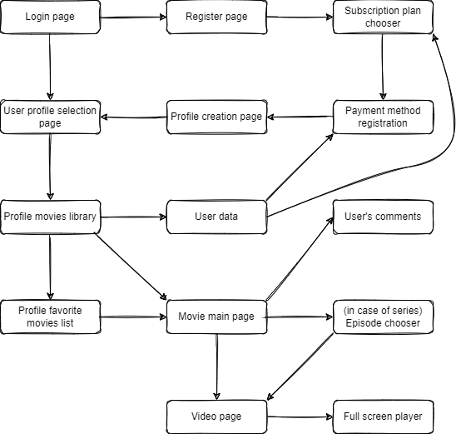

Figure 2. Web/app client map

# Models

Design and layouts of the app inspired by the one of the most popular platforms – Netflix. In this section provided only small part of models or layouts.

**Login Page (Register Page[1], Payment Method Registration Page[2])**

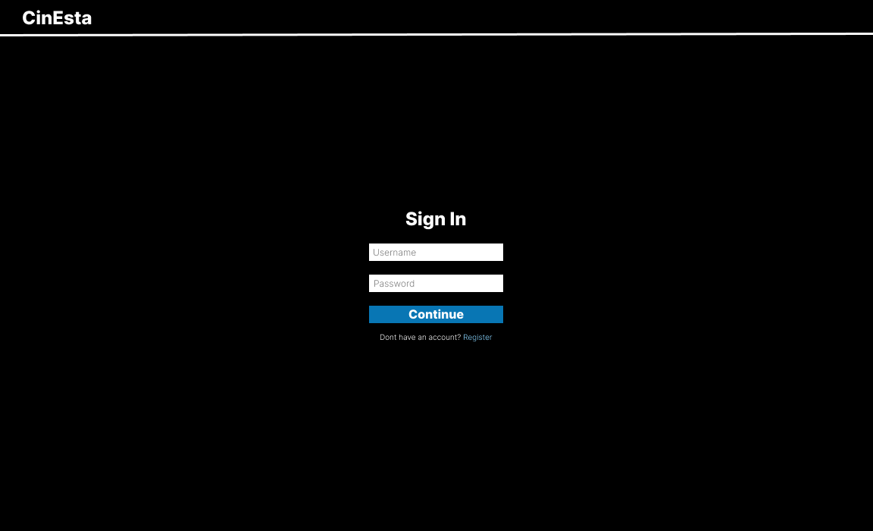

Figure 3. Login page model

**Subscription Plan Chooser**

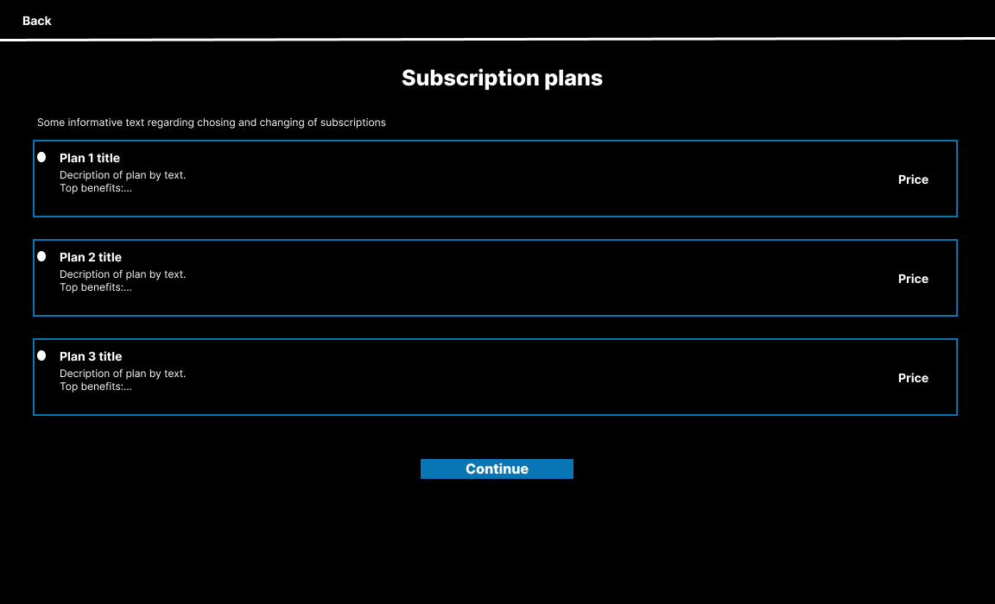

Figure 4.Subscription plan chooser model

**Profile Creation Page (Profile Selection Page[3])**

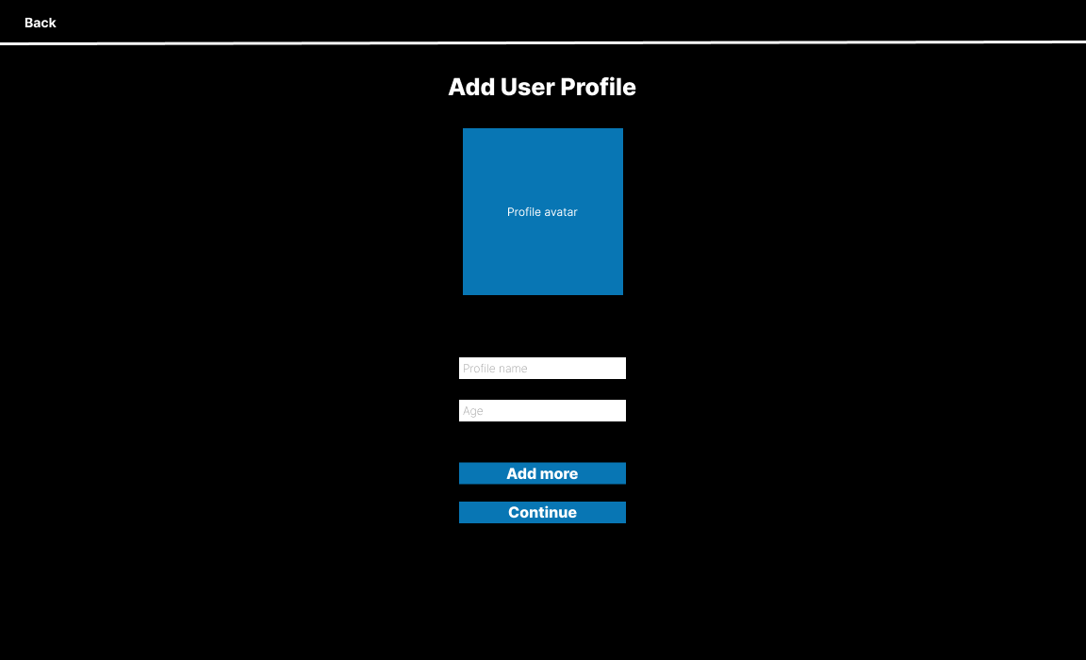

Figure 5. Profile creation page model

**Profile Movies Library (Profile Favorite Movies List[4])**

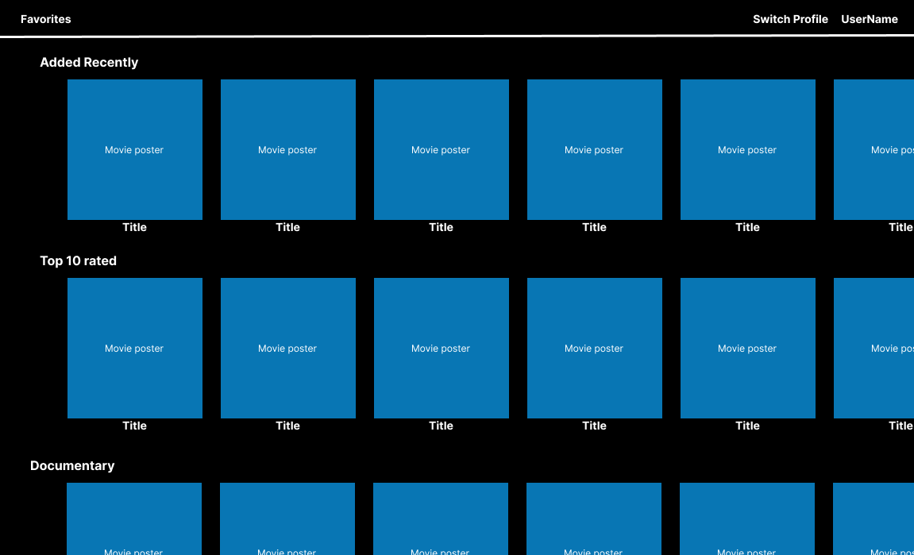

Figure 6. Profile Movies Library model

Project summary

Overall, the back-end part of project, especially database itself looks very easy to implement. The main difficult is to provide good user interface, considering variety and potential amount of Estonian Cinema movies.

Most probably, the author will deviate from inspired by Netflix layout and design, to reduce UI complexity, but save content and improve usability.

1. Logo “CinEsta” substitutes “Back” button. “Sign In” substitutes “Sign Up”. Additional fields for name, surname, and e-mail. Bottom link removed.
2. Logo “CinEsta” substitutes “Back” button. “Sign In” substitutes “Add Credit Card”. Fields substituted by card type, card number, validity, ccv. Bottom link removed.
3. Same model may be used for user profile selection page base. Profile avatars with names placed in row. Button add more and fields removed.
4. Same layout model